Project Member

* Sarah
* Gargi
* Pournima
* Nitin

Project Design

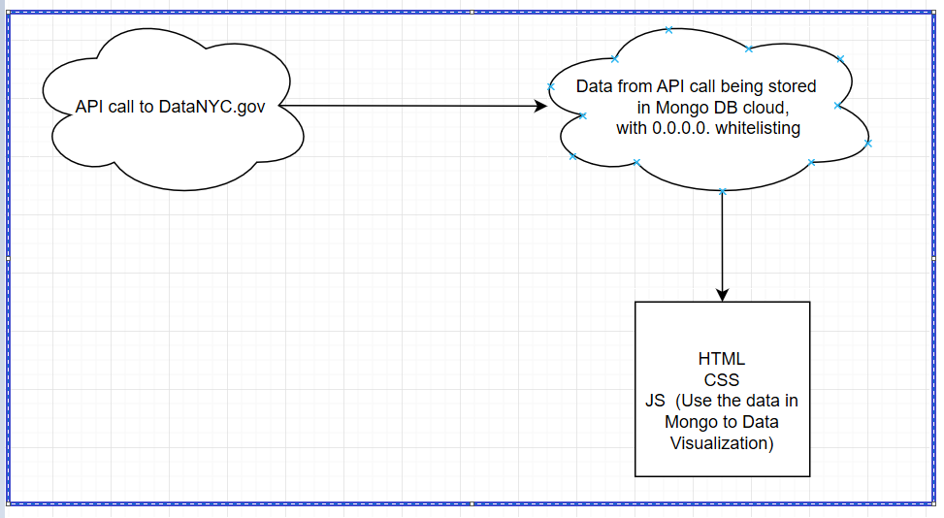

Responsibilities

Getting data and uploading into Mongo DB (Nitin)

Making Cloud account for Mongo DB (Nitin)

Make a cloud sandbox (Nitin)

HTML File (Pournima)

CSS File (Sarah & Gargi)

JS Logic (Sarah & Gargi)

Config file (Nitin)